BI
Mini Project
Analysis & Reporting System of
Bank Account Details

Document Control
Table of Contents
Reference No:
Security Classification: | iGATE Internal
Issue Date:
Author(s): | Name |  | Title
Author(s): | Rajita Dhumal |  | Dy Manager
Reviewer(s): | Name |  | Title
Issuer(s): | Name |  | Title
Issuer(s): | Rajita Dhumal |  | Dy Manager
Issuer Signature(s):
Distribution: | Name |  | Title
Distribution: | iLEARN |  | All Designations in iLEARN
Document History: | Date | Revision | Change
Document History: | Apr 2014 | 1.0 | Document creation
1 Introduction 4
1.1 Setup Checklist for Mini Project 4
1.2 Instructions 4
2 Problem Statement 5
2.1 Objective 5
2.2 Abstract of the project 5
2.3 Technology used: 5
3 Implementation in BI LOT 6
3.1 Summary of the functionality to be built: 6
3.2 Guidelines on the functionality to be built: 7
4 Evaluation and assessment parameters 11

Introduction

This document outlines a mini project for the BI LOT. The project is to develop Analysis & Reporting System of Bank Account Details
This document contains the work flow of the system and gives guidelines on how to build the functionality gradually in each of the course modules of the BI LOT.

Setup Checklist for Mini Project
Minimum System Requirements
- Intel Pentium 90 or higher (P166 recommended)
- Microsoft Windows 95, 98, or NT 4.0, 2k, XP, Windows 2007.
- Memory: 32MB of RAM (64MB or more recommended)
- Internet Explorer 6.0 or higher
- Oracle 9i client and access to oracle 9i server
- Informatica 9.5.1
- BOXI R4

Instructions
- The code modules in the mini project should follow all the coding standards.
- Create a directory by your name in drive <drive>. In this directory, create a subdirectory MiniProject. Store your Project here.
- You can refer to your course material.
- You may also look up the help provided in the BI docs and documentation provided with Informatica and Business Objects.

Problem Statement

Objective
Development of a Analysis & Reporting System of Bank Account Details

Abstract of the project
The project is to develop Analysis & Reporting System of Bank Account Details of the IT Employees

Technology used:
- Oracle 9i (Database)
- Informatica power center
- SQL Server Reporting Services

Implementation in BI LOT

Summary of the functionality to be built:
The participants need to develop the Analysis & Reporting System of Bank Account Details by building the functionality incrementally in each of the course modules of BI LOT.

Sr. No | Course | Duration | No. of Saturdays | Functionality to be built
Sr. No | Course | (in PDs) | No. of Saturdays | Functionality to be built
1. | Programming Foundation using Pseudo code | 5 | 2
3. | Oracle | 7 | 2
4. | Unix | 4 | 2
5. | Oracle Test | 1 | 2
6. | Informatica | 6 | 1 | Perform ETL to generate the fact tables and Dimension tables.
6. | Informatica Test | 1 | 1
7 | OBIEE | 5.5 | 1
8 | OBIEE Test | 1 | 1
9 | SQL Server | 2 | 1
10 | SSRS | 4 | 1

Guidelines on the functionality to be built:

Project flow

Heterogeneous Sources i.e. operational data (Flat files)
EXTRACT
TRANSFORM
LOAD
Data warehouse (Oracle)
Reports Based On Universe
UNIVERSE
(Informatica)
(BO IDT)
(BO XI Rich WebI/WebI)

Schema Design:

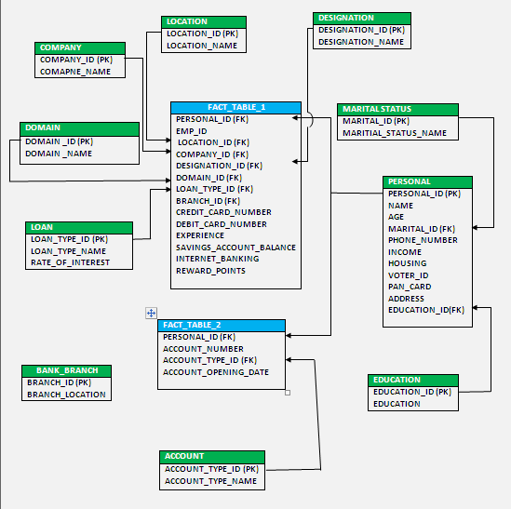
The Dimension tables are
  - Account_type
  - Branch_location
  - Company_Location
  - Company_Names
  - Designation_Details
  - Domain
  - Loan_Type
  - Marital_Status
  - Personal_Details

Fact Tables are
- Bank_Fact1
- Bank_Fact2

Details of the schema objects are:

- Account_type:

This dimension table contains information about the types of account available in bank.
This CSV file comprises of the following Fields:
- Acc_Type_Id
- Acc_Type_name

There are five account types and they are Savings Bank account (SB), Cumulative Deposit account (CD), Fixed Deposit account (FD), Over Draft account (OD), Current account (C)

- Branch_location:

This dimension table contains information about the home branch location of bank.
This CSV file comprises of the following Fields:
- Branch_Id
- Branch_location

There are 12 locations and they are Bangalore, Chennai, Gandhinagar, Navi Mumbai , Pune, Noida, Delhi , Mumbai, Hyderabad, Kolkata, Indore , Jaipur , Calicut.

- Company_location:

This dimension table contains information about the location of the company.
This CSV file comprises of the following fields :
- Location_id
- Location
There are 10 locations and they are Bangalore, Chennai, Delhi , Gandhi Nagar, Hyderabad, Jaipur, Mumbai, Navi Mumbai , Noida ,Pune.

- Company_Names:

This dimension table contains information about the company.
This CSV file comprises of the following fields :
- Company_id
- Company_name
There are 12 companies and they are Accenture, Capgemini, Cognizant, Global Edge, IBM, IGATE, Infosys, Qualcomm, Siemens, TCS, Tech Mahindra, Wipro

- Designation_Details:

This dimension table contains information about the designation of the customer in the company.
This CSV file comprises of the following fields:
- Designation_id
- Designation
There are 11 designations and they are Application Developer, Assistant Software Engineer, Embedded Engineer, HR, Network Engineer, Programmer Analyst, Senior Software Engineer, Software Engineer, System Analyst, System Engineer, Test Engineer.

- Domain:
This dimension table contains information about the domains in customer’s company.
This CSV file comprises of the following fields :
- Domain_id
- Domain_name

There are 59 domains of work handled by the customers of the bank and they are
Business Intelligence, J2EE , ABAP , V&V , Dotnet , mainframes, Systems, C# , Android, C++ , Objective C, iOS, Cobol, HTML , Expression Blende Applications, DOS, Shell scripting, python, Perl, PHP, Javascript, C, VB.Net, real time systems, Device drivers, socket programming, signal processing, real time operations, custom firmware, kernel developers, redhat, Oboto , Solaris, system administrator , Informatica, JDK, BOXi, D2K, TCp , protocol layer designers, Bluetooth, Wireless, redtakon, Socket designer, Network Administrator, Cloud computing , MySQL server, step 7 lite tool, Communication ports, exception handling –recovery, Windows 7.5 ,Windows 8.0 Mobile, Windows 8.1PC, Blackberry 10, Chrome OS App, On-site relations, project allotments, location allotments, hiring

- Loan_type :
This dimension table contains information about the type of loan sanctioned to the customers.
This CSV file comprises of the following fields:
- Loan_type_id
- Loan_type
There are 10 types of loans sanctioned to the customers and they are
Demand loan, education loan, housing loan, Jewel loan, Loans on deposits, Marriage loan, property loan, personal loan, vehicle loan, not applicable

- Marital status:
This dimension table contains information about the marital status of the customers.
This CSV file comprises of the following fields :
- M_code
- Marital_status

- Personal_Details:
This dimension table contains information all the personal details of the customers of the bank.
This CSV file comprises of the following fields:
- Name
- Age
- Marital_id
- Phone number
- Income
- Housing
- Voter ID
- PAN card
- Address
- Location_ID

FACT Tables:

- Bank_fact1:
This fact table contains personal_id, emp_id, company_id, designation_id, domain_id, experience, location_id, branch_id, savings_account_balance, debit card no, credit card no, loan_type_id, rewards points, internet_banking
- Bank_fact2:
This fact table contains personal_id, account_type_id, account_number, account_opening_date.

Note: The datatype/length for the Dimension/Fact table attribues can be changed as required. Additional fields can be added, if required.

Sample Reports

- Top ten bank accounts in terms of balance
- Analysis based on marital status and housing to provide loans
- Analysis grouping on age and education
- Based on no of account holders from the company –count of particular company
- based on account opening date
- based on income – income tax savings=(income-2lac)*tax%
- based on age- retirement policies
- based on experience – policies /offers=experience (based on their likings)
- Based on region to establish more banking portals-count of all locations
- Based on reward points – offers
- no of similar types of account –count of all same types of Based on accounts
- Based on no of similar types of loan
  - interest rates
  - reduction of interest rate for older accountholders=(acc opening date-current date)>some yrs a) for a specific loan type
- Based on net interest percent on the amount deposited=avg interest amount

Referred to the shared source files.

Evaluation and assessment parameters
This mini project will be done in groups of five or six. Each group will identify a Team Lead who will decide which team member will code for which functionality. This project shall be evaluated in two phases. Evaluation will be done using online presentation mode, where each group will present their respective modules.

Evaluation Parameters (100 Marks)
- ETL Scripts and DW design (25)
The extent to which the ETL was performed, the transformations used
Deliverables in terms of time lines
- Universe Design (35)
The way the universe was designed with appropriate classes and objects, conditions created
- Deliverables(Reports) (40)
Presentation of reports.

